INTELLISUITE Documentation

Step 1 : Design the mask file in the Intelli Mask module required for the structure to be simulated.

Step 2 : Import the designed mask file into the 3D-Builder module

Step 3 : Perform TEM Analysis of the designed structure in TEM module

Step 4 : Import the same mask file in the Intelli Fab module for the visualisation of the structure after fabrication

**Intelli Mask module**

Step 1 : Draw the mask structure for keeping the ends of the V-beams and the curved beam fixed in layer 0.

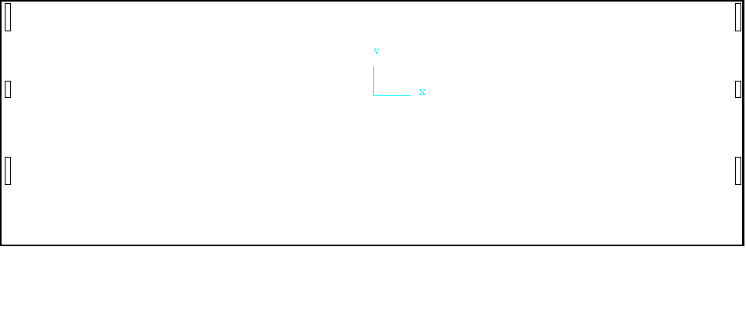Step 2 : Draw the mask structure of the device in layer 1.

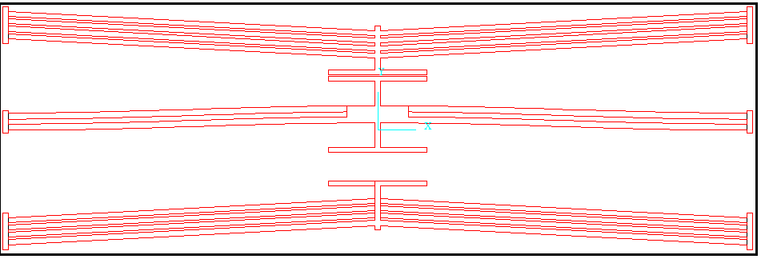

Step 3 : Draw the mask structure of the contact pads in layer 2.

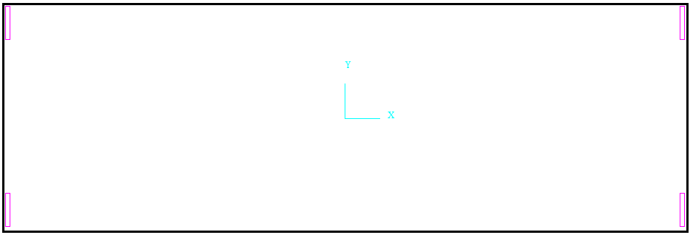

Step 4 : Draw the mask structure creating a trench under the device providing only a rectangular beam support around the device structure.

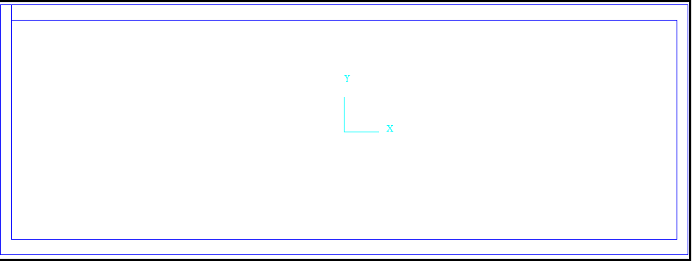

**3D Builder module**

Step 1 : Import the designed mask file in the 3D Builder module.

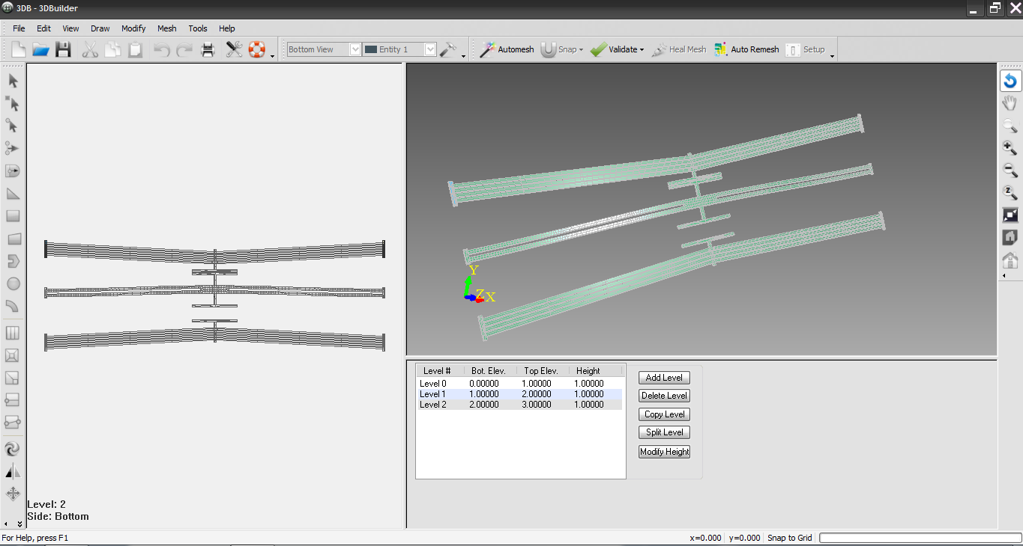

Step 2 : Adjust the layer height of the contact pads.

Step 3 : Export the design to TEM module.

**TEM Module**

Step 1 : Setting the simulation settings.

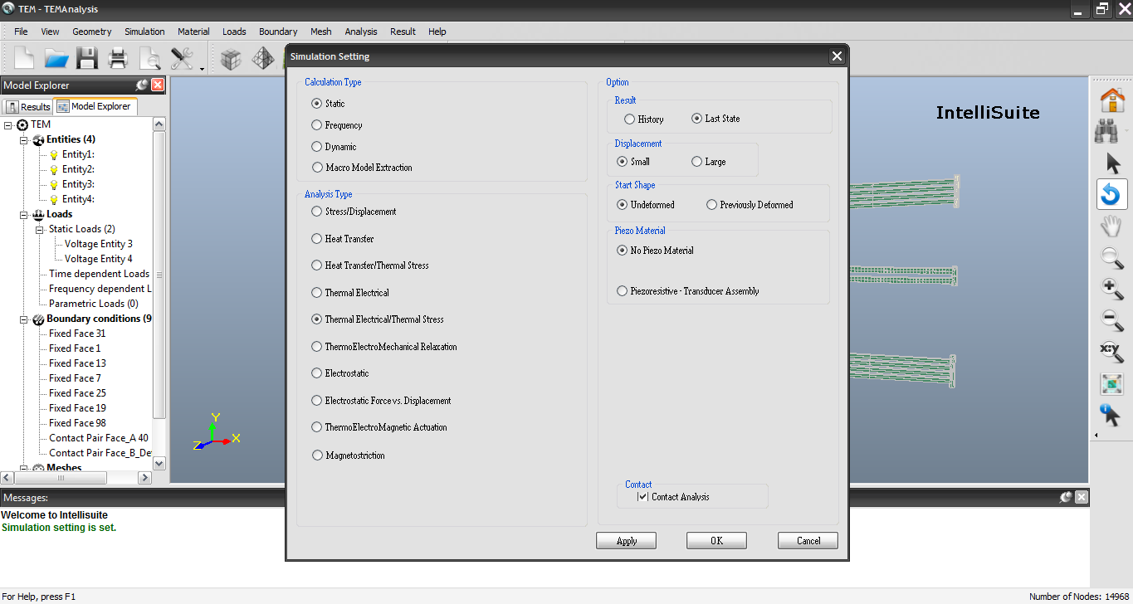

Step 2: Applying voltage to the V-beam actuator

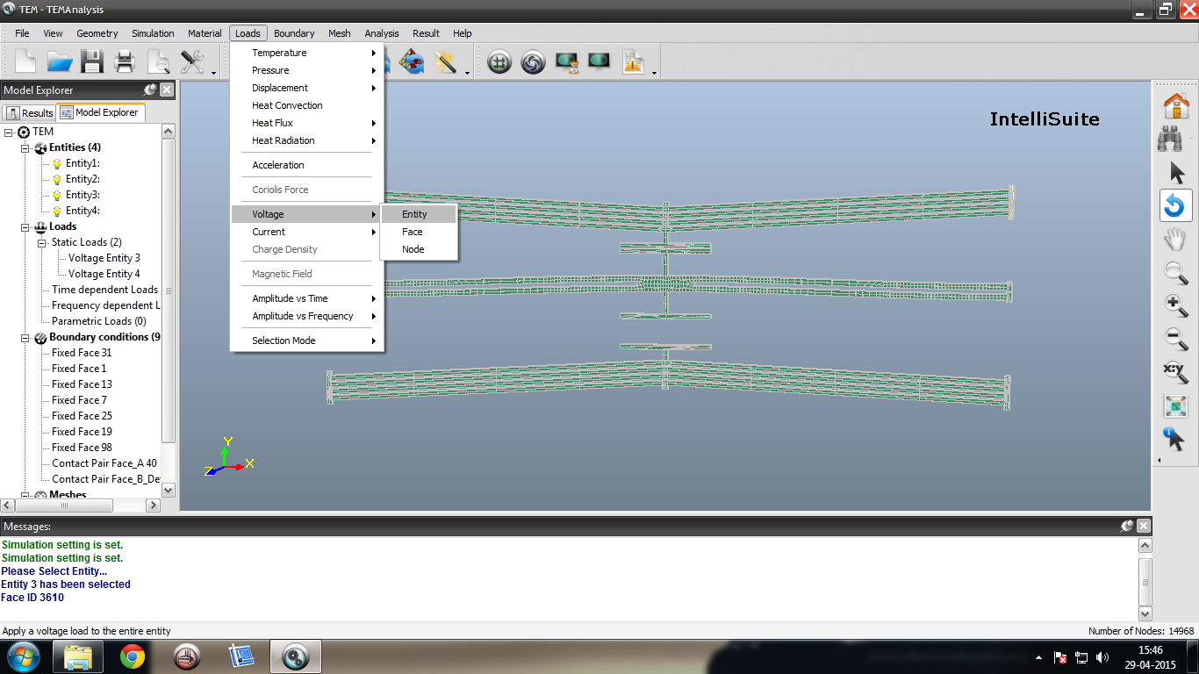

Step 3 : Applying boundary conditions to keep the ends of the V-beams and the curved beam fixed

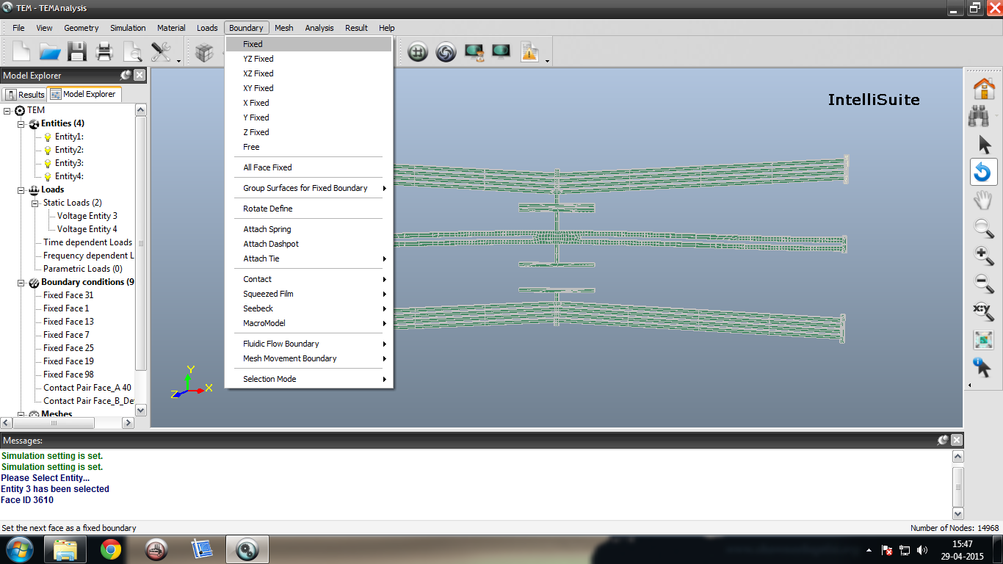

Step 4 : Assigning material to the device structure

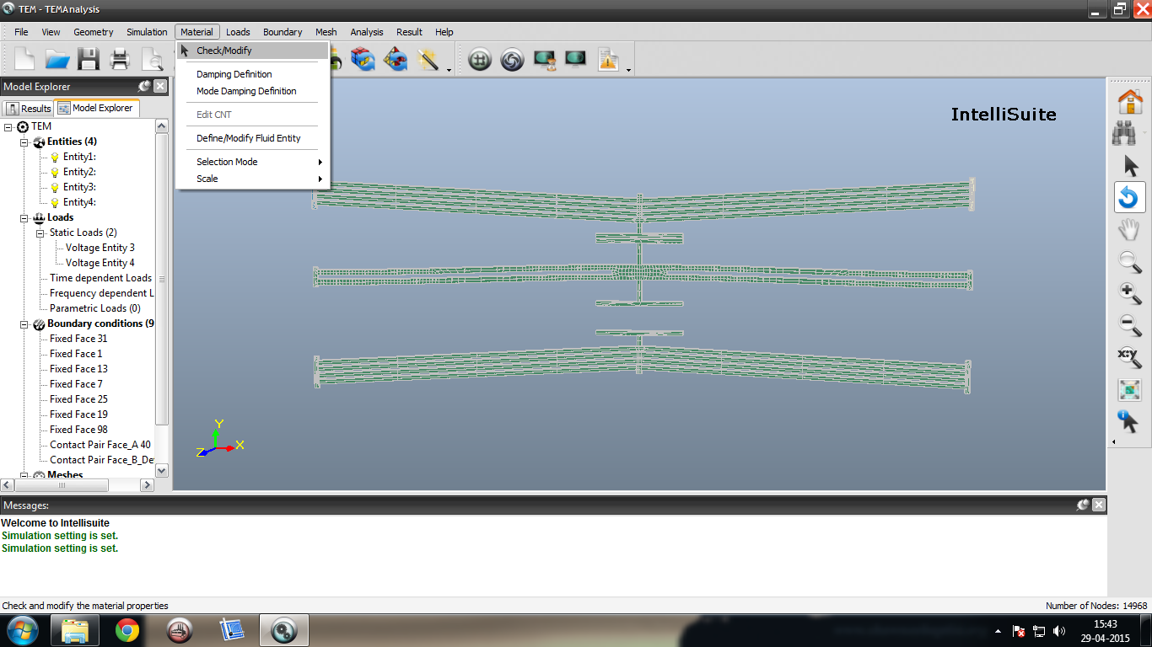

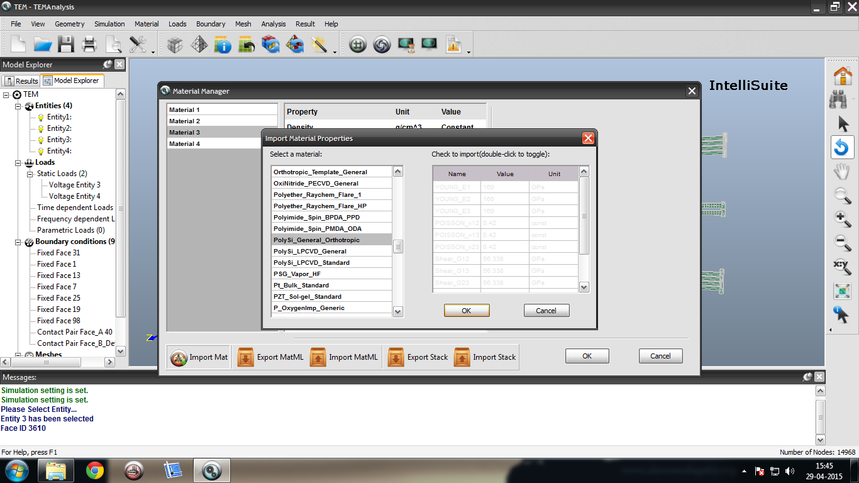

Step 5 : Enabling contact between the V-beam actuator and the curved beam

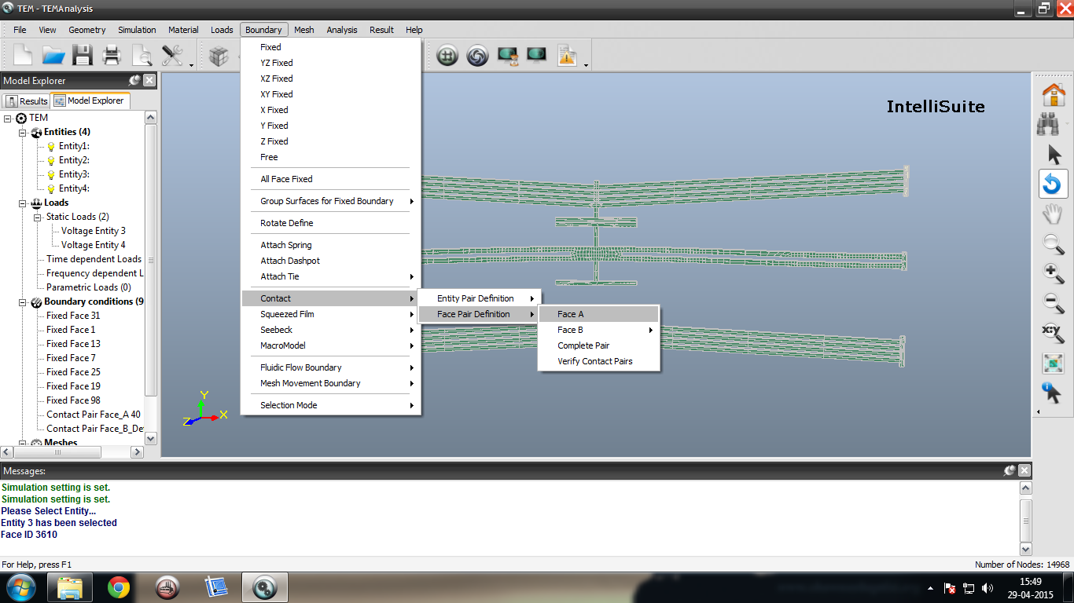

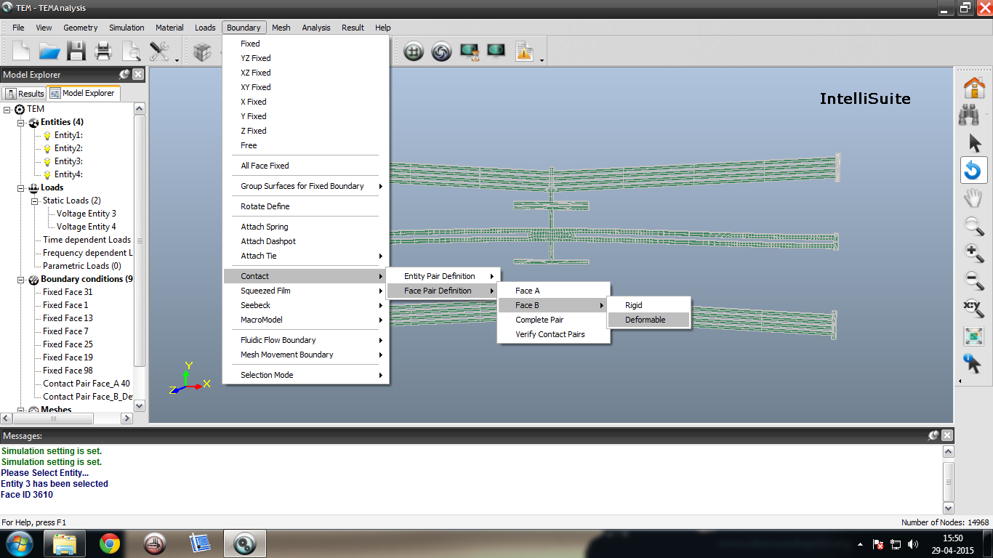

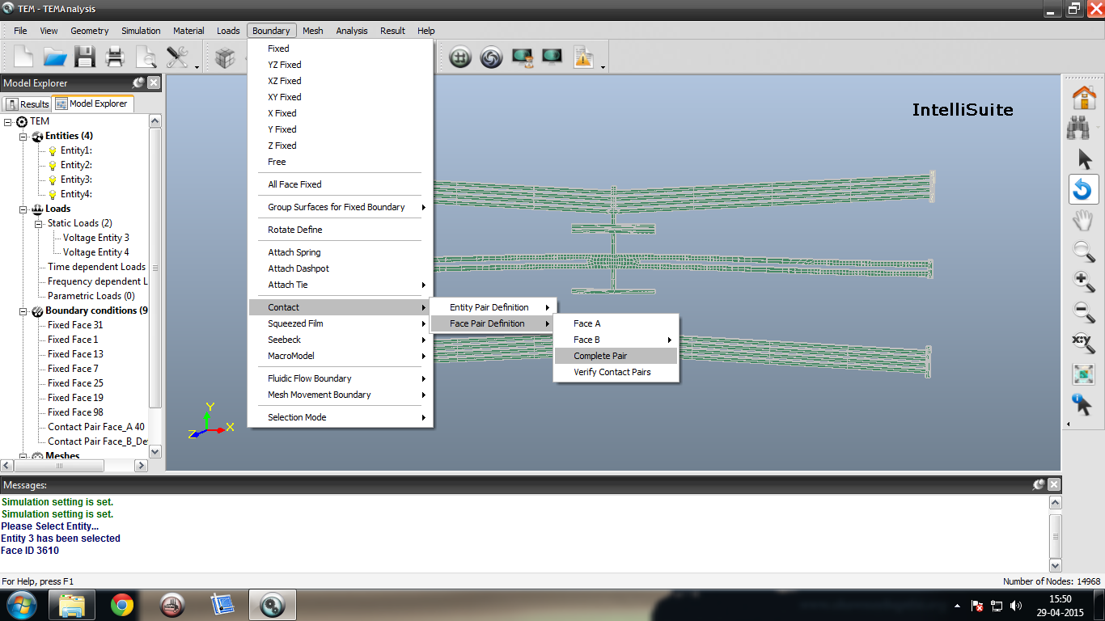

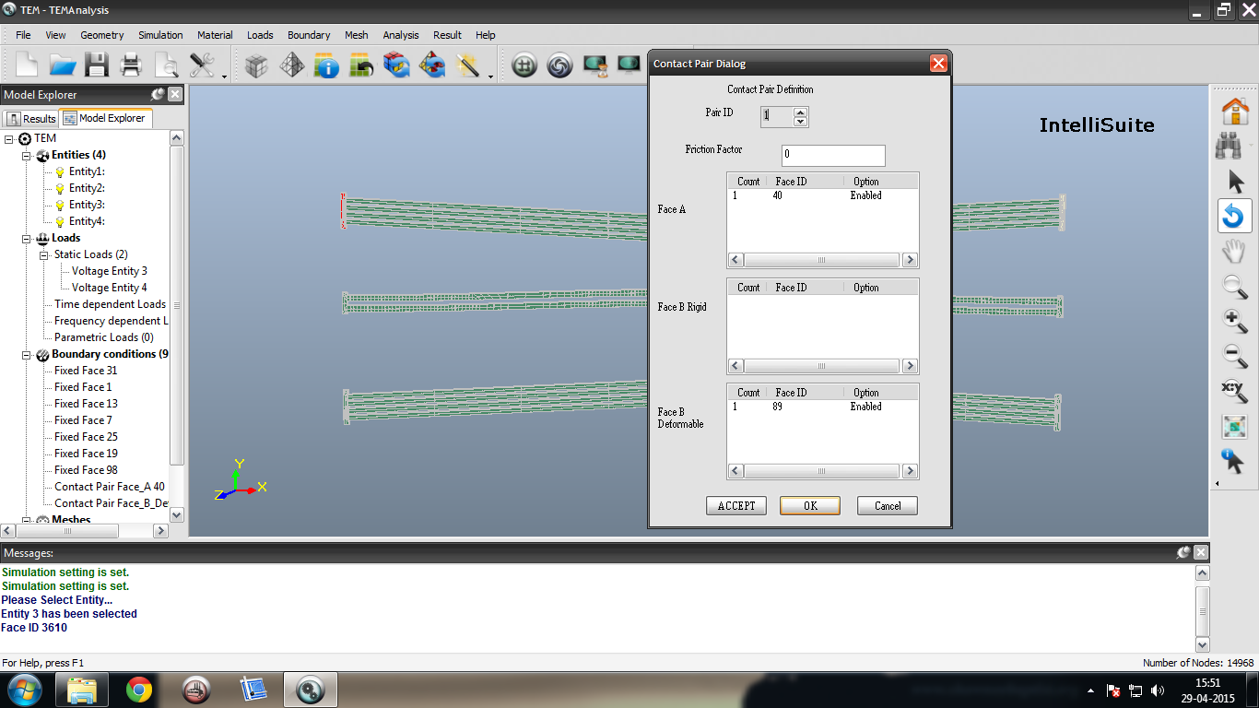

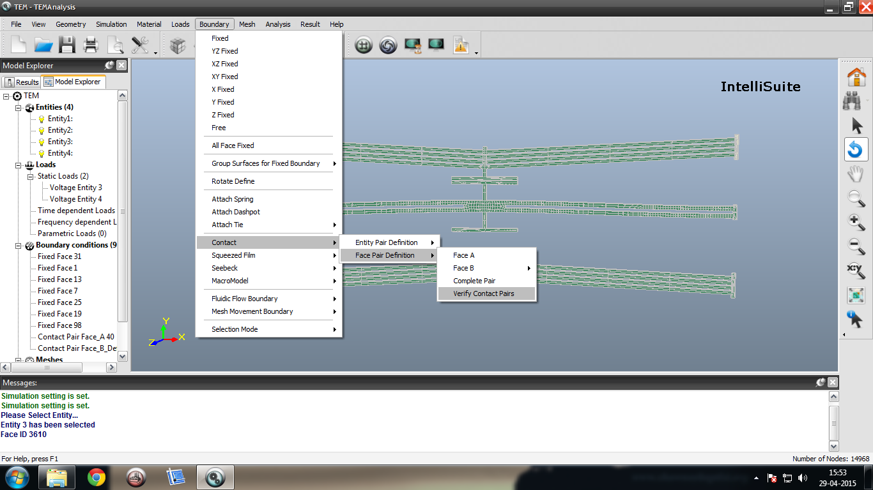

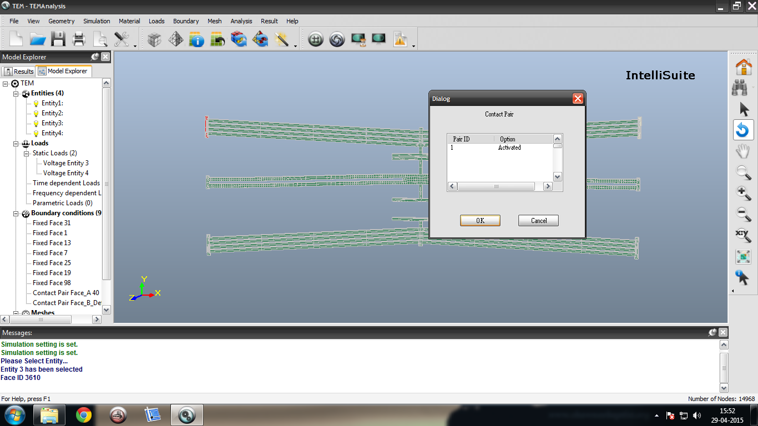

Step 6 : Analysing the design

